# State’s Descriptions of the General Supervision System

MS Word Template

September 2021

Nancy O'Hara

Nicole Garcia

Susan Hayes

Mary Watson

Teri Williams Valentine

## About the template

This template is designed to assist states in developing a broad overview of their general supervision system. It is not intended to be a monitoring or dispute resolution manual that includes detailed information about how those specific aspects of the system function. The template is fully customizable and we invite users to add to it or delete from it as needed to fit their own particular use and context. Please reach out to your NCSI facilitator for support as needed.

NCSI created this template for state staff to use to describe their system of general supervision. The final product can be shared with various stakeholders to communicate the overall purpose and vision of the system and how the various components of the system interact to support local education agencies (LEAs) improve outcomes for children and youth with disabilities as well as maintain compliance with the IDEA.

© 2021 by WestEd—National Center for Systemic Improvement. All rights reserved.

*NCSI includes staff from the OSEP funded Parent Training and Information Centers and Regional Parent TA Centers and the OESE funded Statewide Family Engagement Centers.*

*The content of this document was developed under a grant from the US Department of Education, #H326R190001. However, those contents do not necessarily represent the policy of the US Department of Education, and you should not assume endorsement by the Federal Government. Project Officer: Perry Williams (October 2019)*

*WestEd is the lead organization for NCSI. For more information about the work of WestEd, NCSI, and their partners, please visit* [*www.ncsi.wested.org*](http://www.ncsi.wested.org/) *and* [*www.wested.org*](http://www.wested.org/)*.*

## Choose a design Modify or create your own design

### Directions for use:

#### Page 5: Cover page

* Decide whether to keep the puzzle piece image or create your own graphic about your system of general supervision. NCSI can make access to an infographic software available to all states for this purpose. Reach out to your NCSI facilitator for information on how to access the Venngage infographic development website. See next page for infographic examples you can edit for your state or you can create a new graphic.
* Paste graphic onto the cover page.
* Insert date into footer so you know last revision date.

#### Page 6: Description of the system

* Include the name of your system (if applicable) in the page title.
* Develop a written description of your system with the emphasis on (1) how the system components are integrated and work together; and (2) how the system results in improved compliance and results for children with disabilities.
* Replace graphic with graphic of your choice as appropriate.

#### Page 7: Vision of the state system

* Use the questions in the template to help define the state’s vision for its system of general supervision.
* Replace the graphic with graphic of your choice as appropriate.

#### Page 8: Fiscal Management (through page 12 SPP/APR, for each page)

* Review the working definition of the section and adapt it to fit the context of your state.
* Describe how the system component interacts with the other relevant components of the state’s general supervision system.
* Replace graphic as appropriate.

Decide whether to use an existing the graphic template or create your own design.

The examples shown below were made using Venngage, an online infographics tool.

Please contact your NCSI facilitator for information on how to access the Venngage through NCSI.

### Example Designs:

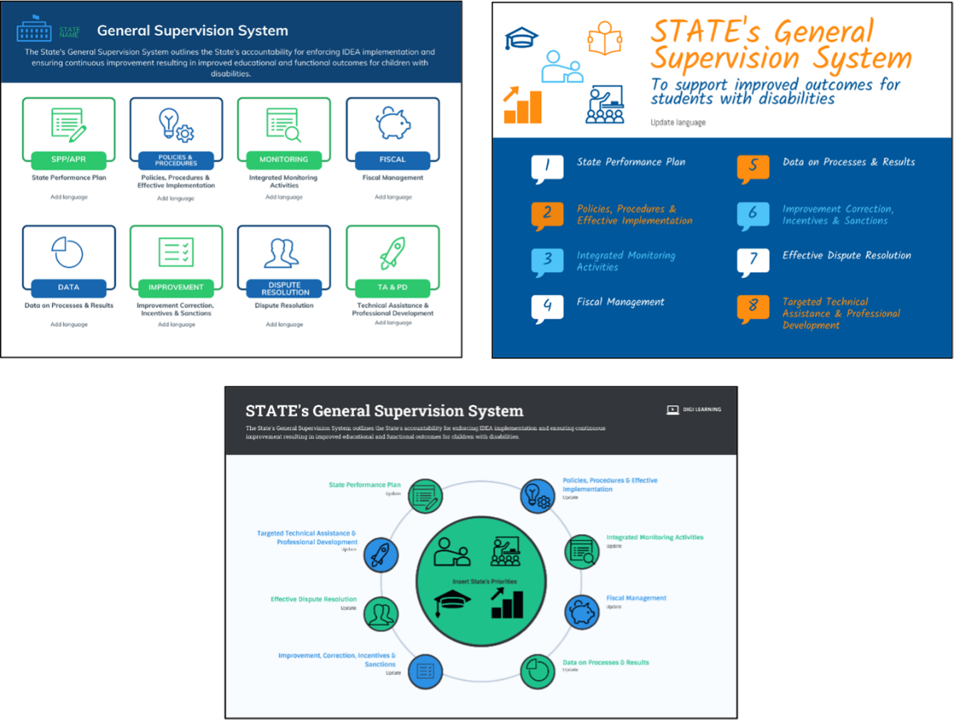

# [State name]



# System of

# General Supervision

## Author Name

## Author Name

## Author Name

## Overview of the [State Name] System of General Supervision

The graphic below shows the core components of the state’s general supervision system.

Puzzle pieces connecting to each other. Each puzzle piece indicates the following:
Fiscal Management, Integrated Monitoring, Sustaining Compliance & Improvement, Implementation of Policies & Procedures, Technical Assistance & Professional Development, Dispute Resolution, Data, SPP/APR

Note: This graphic may be replaced with a graphic designed by the state. NCSI can provide each state with access to software for creating infographics. Contact your NCSI TA facilitator for more information.

* *Use this section to provide a brief description of your state’s general supervision system.*
* *How are the components of General Supervision coordinated and how do they work together to improve compliance and outcomes for students with disabilities in your state?*

## Vision for the [state name] System of General Supervision

Vision Overview: Use this section to describe the high-level vision of your state’s general supervision system. What does success for students with disabilities look like?

### What are Our Goals for Students with Disabilities?

* *Use this section to describe your state’s high-level goals and vision for students with disabilities.*
* *What is the ultimate goal for students with disabilities in your state?*

### How will we reach our goals?

* *Use this section to describe how schools and districts should work to support students to reach the goals set in this document.*
* *How will we reach our goals?*

### What is the role of the State Education Agency?

* *Use this section to describe the role of the State Educational Agency within your general supervision system.*
* *How will the State Educational Agency work to assist in creating a general supervision system that supports schools and districts to help students to reach the goals set in this document?*

### What is the relationship between compliance and student outcomes?

* *Use this section to describe what you see as the relationship between compliance with IDEA and improving student outcomes.*
* *What will successful implementation of IDEA look like in terms of outcomes for students with disabilities?*

## Components of the [State name] System of General Supervision

### Fiscal Management



The state system of General Supervision includes mechanisms to provide oversight in the distribution of and use of funds according to federal and state requirements. States must provide oversight with the use of funds.

* *How does your state define/describe its Fiscal Management system? Delete or modify the working definition above.*
* *Describe how the state’s Fiscal Management system is integrated with the other relevant components of its System of General Supervision?*

### Integrated Monitoring



Effective monitoring strategies are integrated across all components of the general supervision system. Multiple data sources and methods must be used to monitor every LEA. Selected monitoring activities must ensure continuous examination of performance for compliance and results. This includes on-site and off-site monitoring activities. Monitoring protocols should focus on specific priority areas selected based on state performance.

* *How does your state define/describe its Integrated Monitoring system? Delete or modify the working definition above.*
* *Describe how the state’s Integrated Monitoring system is integrated with the other relevant components of its System of General Supervision.*

### Sustaining Compliance and Improvement



Supporting improvement and ensuring correction are critical components of a General Supervision System. This includes explicit state authority to enforce regulations, policies, and procedures and to use technical assistance to ensure correction of noncompliance. This is about improvement planning to meet state and local targets. There must be a means for corrective action planning and follow up tracking of correction and improvement which includes a range of formalized strategies and written timelines for correction of noncompliance. The status of local programs must be determined annually.

* *How does your state define/describe its system of Sustaining Compliance and Improvement? Delete or modify the working definition above.*
* *Describe how the state’s system of Sustaining Compliance and Improvement is integrated with the other relevant components of its System of General Supervision.*

### Implementation of Policies and Procedures



States must have policies, procedures and effective implementation of practices aligned with IDEA and State Statutes. These are to be implemented by local programs and must include descriptions of methods the state will use to detect non-compliance with IDEA and state laws as well as ensure correction of noncompliance. Program improvement that will improve outcomes for students with disabilities should be encouraged through improvement planning and incentives. Current interagency agreements and memoranda of understanding must be included explaining mechanisms for determining effectiveness of the agreements and MOUs.

* *How does your state define/describe its system for Implementation of Policies and Procedures? Delete or modify the working definition above.*
* *Describe how the state’s system for Implementation of Policies and Procedures is integrated with the other relevant components of its System of General Supervision.*



### Technical Assistance and Professional Development

Technical assistance and Professional Development (TA/PD), as part of an effective system of general supervision, must be directly linked to the SPP/APR indicators and to activities that will improve results and/or compliance. States provide LEAs with a range of assistance to improve performance from minimal assistance to substantial intervention based on need. TA/PD serves multiple functions to assist LEAs in improving results and compliance. TA/PD and capacity building activities can be implemented at varying levels and through multiple means such as websites; documents; coaching; mentoring; training of trainers; local, regional, and/or statewide meetings/conferences; and direct training from state personnel and/or state or regional TA/PD providers.

* *How does your state define/describe its Technical Assistance and Professional Development system? Delete or modify the working definition above.*
* *Describe how Technical Assistance and Professional Development system is integrated with the other relevant components of its System of General Supervision.*

### Dispute Resolution

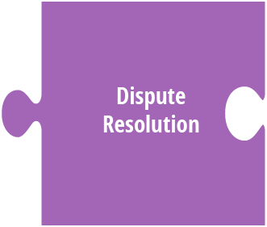

The timely resolution of complaints, mediations, and due process actions is required for compliant dispute resolutions. Effective dispute resolutions also track the issues identified to determine whether patterns or trends exist in the state or in an LEA, Data from dispute resolution systems can inform the state’s TA/PD system and identify priorities for monitoring. Additionally, through the tracking of the issues over time, it is possible for states to evaluate the resolutions’ effectiveness and determine whether resolution was maintained in future situations.

* *How does your state define/describe its Dispute Resolution System? Delete or modify the working definition above.*
* *Describe how the state’s Dispute Resolution is integrated with the other relevant components of its System of General Supervision.*

### Data



As part of the state’s general supervision responsibilities, a chain of events should occur when data are used for decision-making about program management and improvement. These events include:   
1) Collection and verification; 2) Examination and analysis;   
3) Reporting of data; 4) Status determination; and 5) Improvement.

* *How does your state define/describe its Data system? Delete or modify the working definition above.*
* *Describe how the state’s Data system is integrated with the other relevant components of its System of General Supervision.*

### State Performance Plan/Annual Performance Report



The State Performance Plan/Annual Performance (SPP/APR) is an accountability mechanism for states and LEAs. There are 17 Indicators that have been purposely written to provide a measurable indication of a state’s performance in specific statutory priority areas of Part B of the IDEA. Stakeholders should be actively involved in developing all aspects of the SPP. The development and implementation of the plan is intended to lead to improved results for students with disabilities. The SPP/APR is a blueprint for systems change. Reporting is critical to ensuring accountability to the public.

* *How does your state define/describe the SPP/APR system? Delete or modify the working definition above.*
* *Describe how the state’s SPP/APR system is integrated with the other relevant components of its System of General Supervision.*